**DAILY ONLINE ACTIVITIES SUMMARY**

|  |  |  |  |  |  |  |  |  |
| --- | --- | --- | --- | --- | --- | --- | --- | --- |
| **Date:** | **22/05/2020** | | | | | **Name:** | **V ANJANA PAI** | |
| **Sem & Sec** | **IV sem & B section** | | | | | **USN:** | **4AL18CS094** | |
| **Online Test Summary** | | | | | | | | |
| **Subject** | | **OPERATING SYSTEMS** | | | | | | |
| **Max. Marks** | | **30** | | **Score** | | | **21** | |
| **Certification Course Summary** | | | | | | | | |
| **Course** | **Python for Machine Learning** | | | | | | | |
| **Certificate Provider** | | | **Greatlearning academy** | | **Duration** | | | **5.0 hours** |
| **Coding Challenges** | | | | | | | | |
| **Problem Statement1:** Write a C or Java program to implement round robin type of process scheduling. Input: Process with burst time, arrival time and specify the time quantum Output: Processes scheduled based on the round robin type of scheduling, with its average waiting time.  **Problem Statement2:** Write a C Program to implement various operations on Singly Linked List Stack. | | | | | | | | |
| **Status: Executed** | | | | | | | | |
| **Uploaded the report in Github** | | | | | **YES** | | | |
| **If yes Repository name** | | | | | **lockdown-coding** | | | |
| **Uploaded the report in slack** | | | | | **YES** | | | |

Online Test Summary: 18CS43 test was scheduled from 9:15 am t0 9:55am. The portion for the IA was 1st module there were 30 questions and the time assigned was 40 minutes the questions were mcq type.

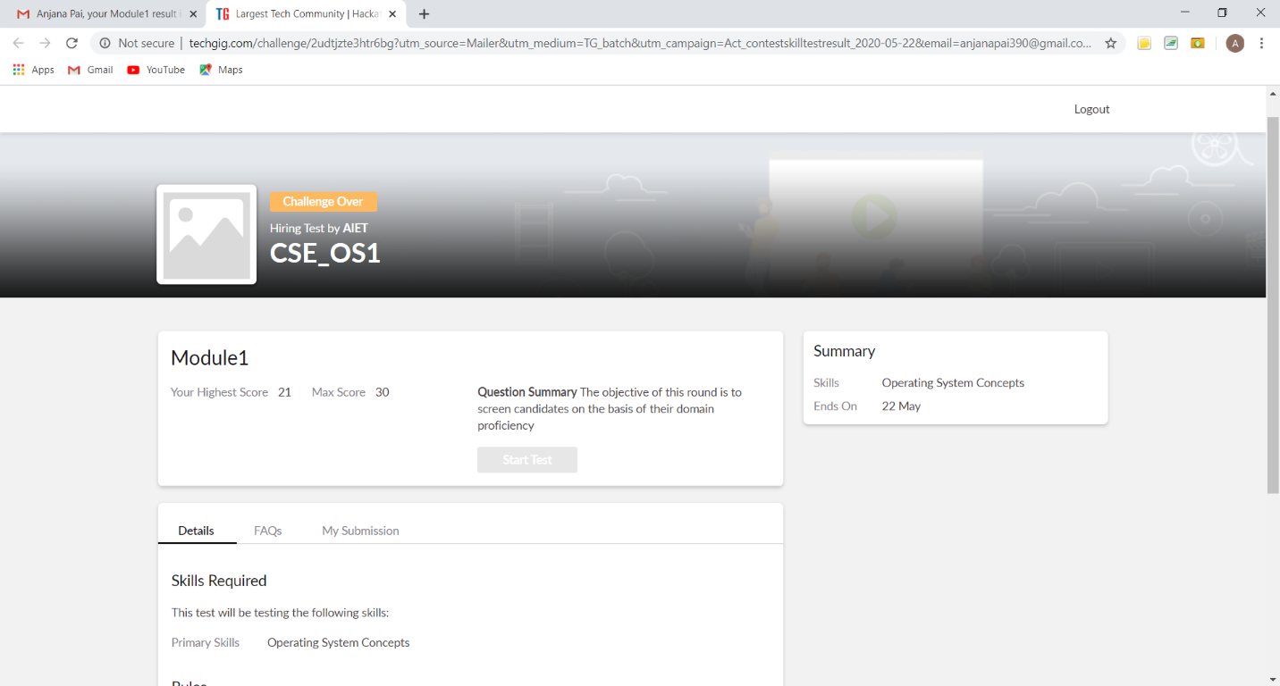

The above snap shot is the completion of the test and the marks allotted.

Online Certification Course Summary: In today’s session I continued with the course on the topic loop. Where I came to know about loops like for, while, nested loop and also some functions like user defined function how it can be used in python and the functions like lambda, filter, map, reducer and accumulator.

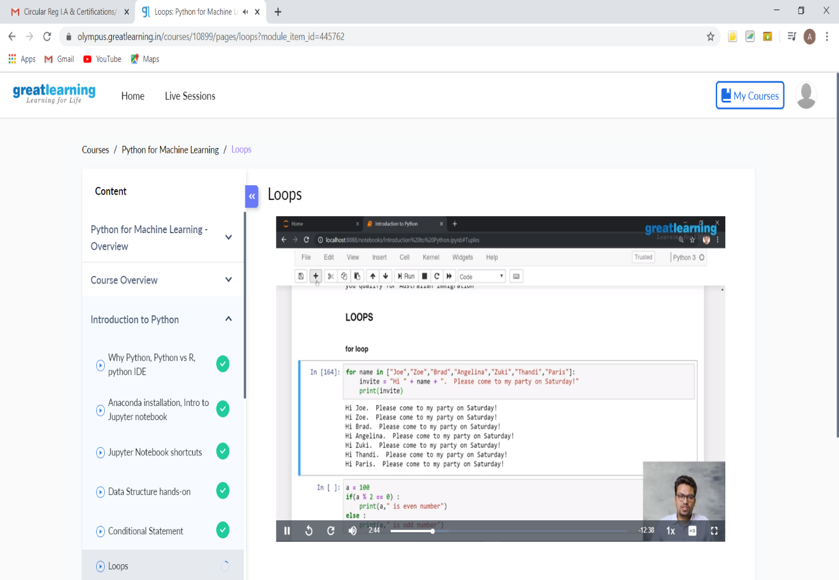

The above mentioned is the snap shot of Today’s Session.

Online Coding Summary: **Today I had received one program prof. Harshitha CSE Dept and another from prof. Venkatesh CSE Dept. The programs are mentioned above in the coding challenges(pg.01). I have also uploaded it to my Github repository.**

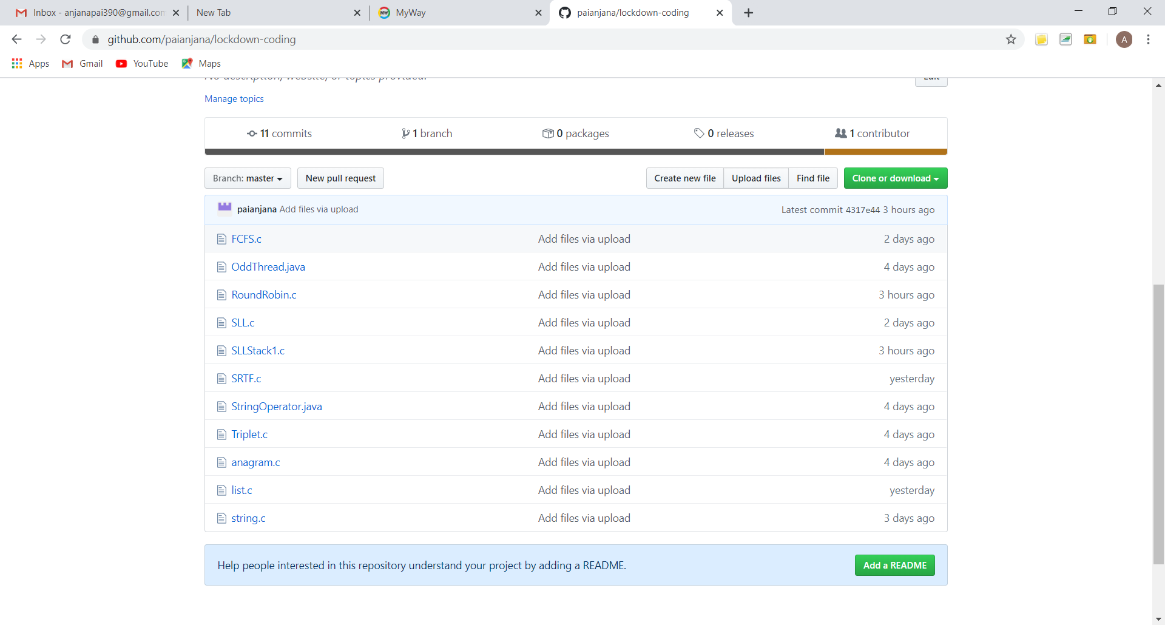

It is the snap shot of my repository where I have uploaded the code. File name is RoundRobin.c and SLLStack1.c